**Lab report #3**

**Sadovskaya Veronika**

GitHub: <https://github.com/sdveronika/DataMola22>

**Task 1 - Export Geo Location Reference**

Create tablespace and user for working with the table by location.

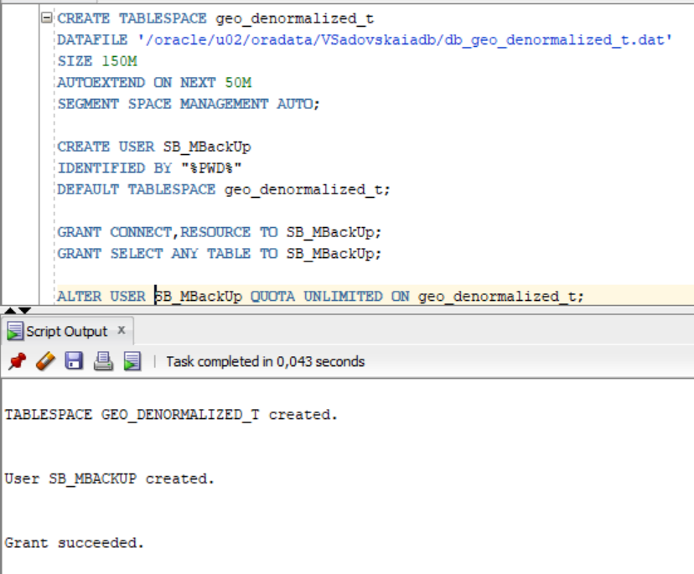

Create demormalized table using CONNECT BY containing additional columns from the task

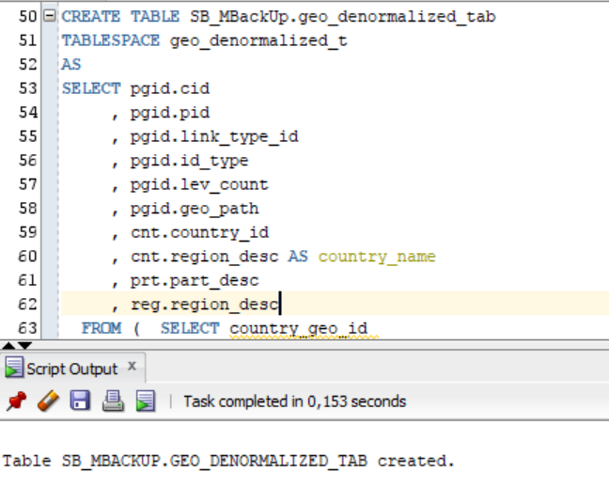

Select from denormalized table.

